Laboratorio 00

**Nombre**: AA

**Carnet**: BB

**Carrera**: CC

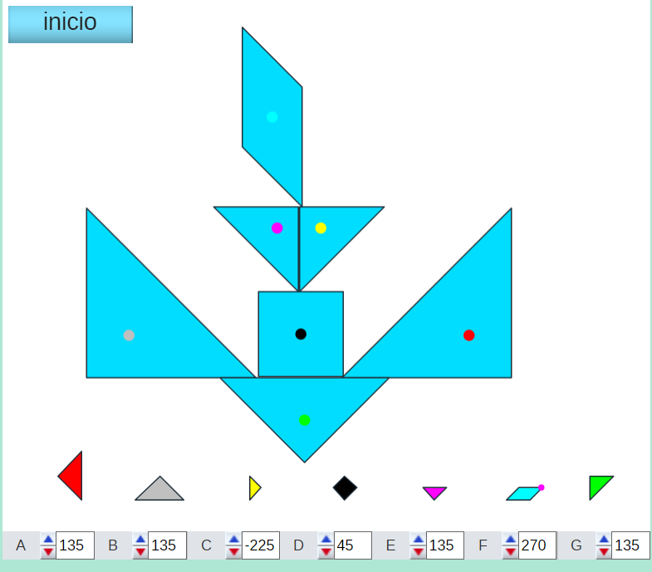

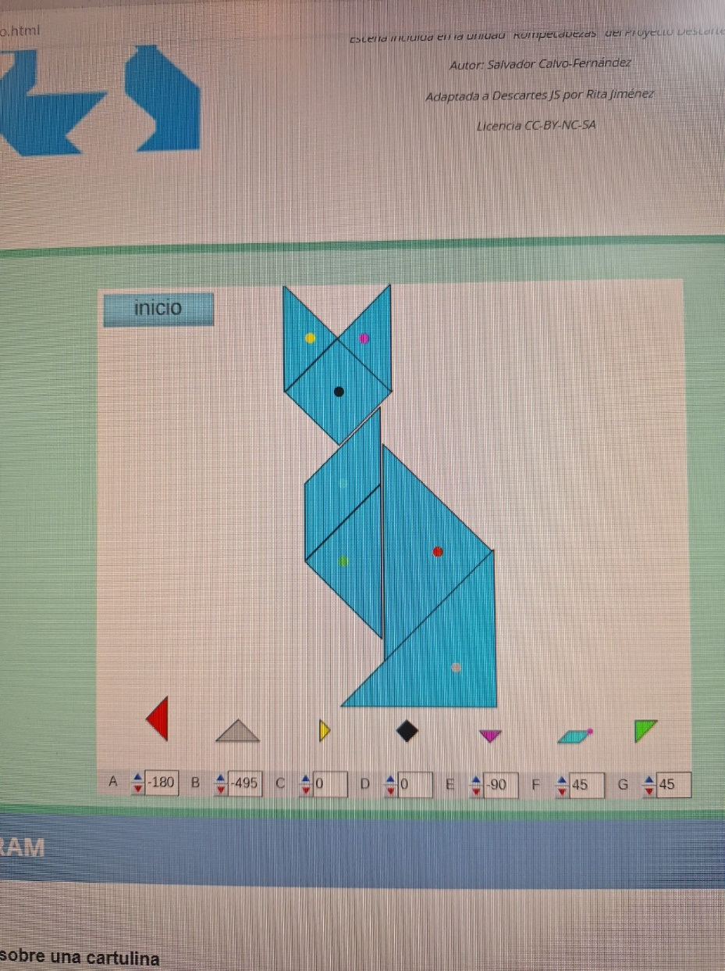

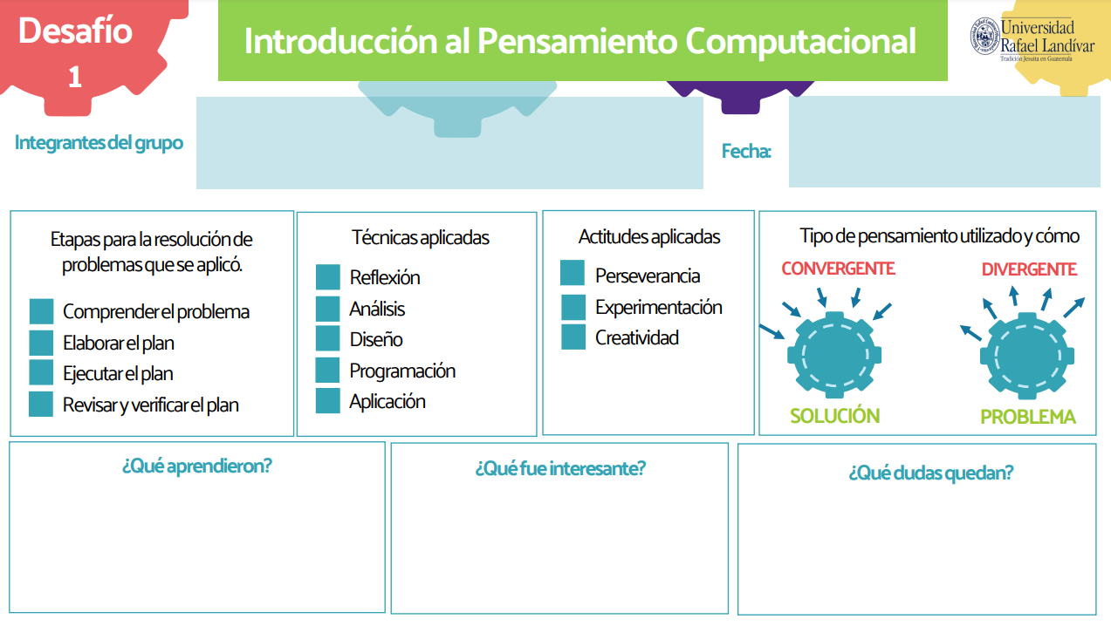

19/01/2024

Juan Martìnez 1253224

Diego Manrique 1197624

C:\Users\Estudiante\AppData\Local\Microsoft\Windows\INetCache\Content.MSO\E6805194.tmpC:\Users\Estudiante\AppData\Local\Microsoft\Windows\INetCache\Content.MSO\E6805194.tmp

C:\Users\Estudiante\AppData\Local\Microsoft\Windows\INetCache\Content.MSO\E6805194.tmpC:\Users\Estudiante\AppData\Local\Microsoft\Windows\INetCache\Content.MSO\E6805194.tmpC:\Users\Estudiante\AppData\Local\Microsoft\Windows\INetCache\Content.MSO\E6805194.tmpC:\Users\Estudiante\AppData\Local\Microsoft\Windows\INetCache\Content.MSO\E6805194.tmpC:\Users\Estudiante\AppData\Local\Microsoft\Windows\INetCache\Content.MSO\E6805194.tmp

C:\Users\Estudiante\AppData\Local\Microsoft\Windows\INetCache\Content.MSO\E6805194.tmpC:\Users\Estudiante\AppData\Local\Microsoft\Windows\INetCache\Content.MSO\E6805194.tmp

C:\Users\Estudiante\AppData\Local\Microsoft\Windows\INetCache\Content.MSO\E6805194.tmpC:\Users\Estudiante\AppData\Local\Microsoft\Windows\INetCache\Content.MSO\E6805194.tmp